**Green Campus Clean campus Cell**

****

**GREEN CAMPUS CLEAN CAMPUS CLUB REPORT 2016-2017**

|  |  |  |
| --- | --- | --- |
| Convener | Dr. T.K. Maqbool | C:\Users\user\Desktop\attachments\IMG_9519.JPG |
| Joint Convener | Smt. Shamila. V.U | C:\Users\user\Desktop\attachments\Shamila Miss Photo.jpg |
|  | Smt. K. Safna | C:\Users\user\Desktop\attachments\IMG_9522.JPG |
|  | Dr. Mujeeb Rahiman | C:\Users\user\Desktop\Mujeeb-Photo.jpg |
| Student Co-Ordinator | Mohamed Shakeel | C:\Users\user\Desktop\attachments\Mohamed Shakeel.jpg |

Clean and Green Campus club was formed on 3/8/2016.

* As a part of cleaning activities, the members were actively participated in the cleaning the garden in front of the campus. The members plucked the weeds and arranged garden pots and planted many floral plants in the campus under the guidance of Prof Maqbool and other co ordinators (Shamila V.U, Safna. K, Mujeeb Rahiman, K.M)

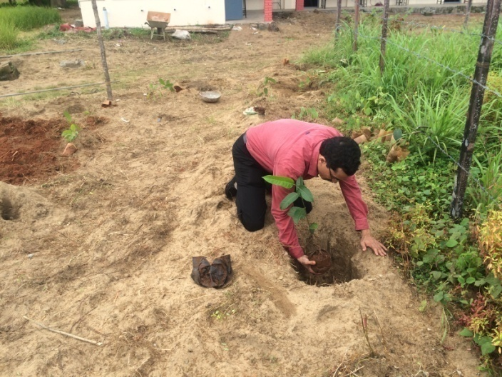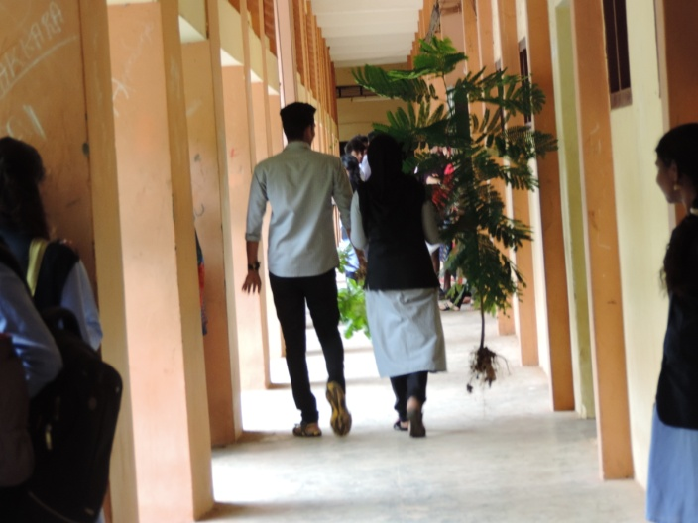

* On August 4th 2016, the club members cleaned and pick plastics in and around the campus

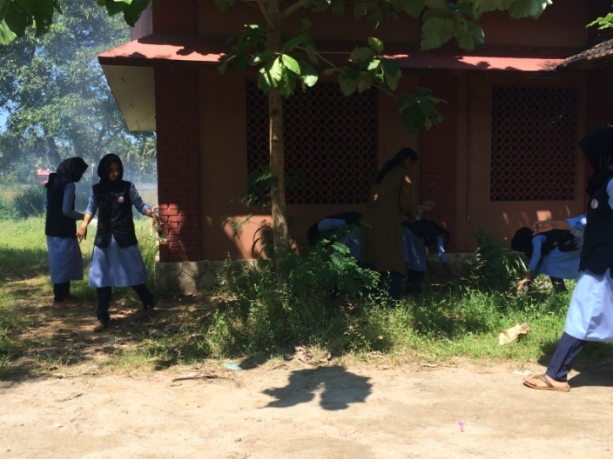

* As a part of organic farming activities initiated in the campus, Mujeeb sir had visited Ponnani Krishi Bhavan and ordered 100 grow bags financed by Principal’s office. The grow bags was received on 13/12/2016. The grow bags was distributed to NSS, NCC, Natura club and College Union. They grew vegetables like Pea, brinjal, tomatoes and chilly. A team is taking care of and watering the plant regularly.

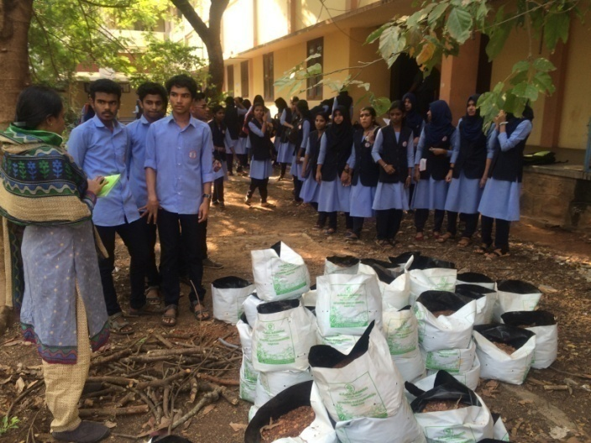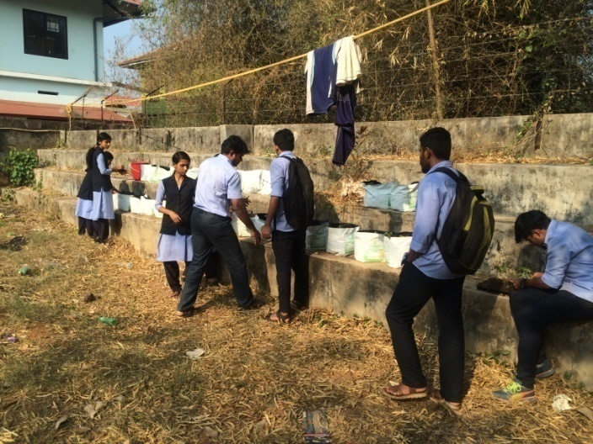

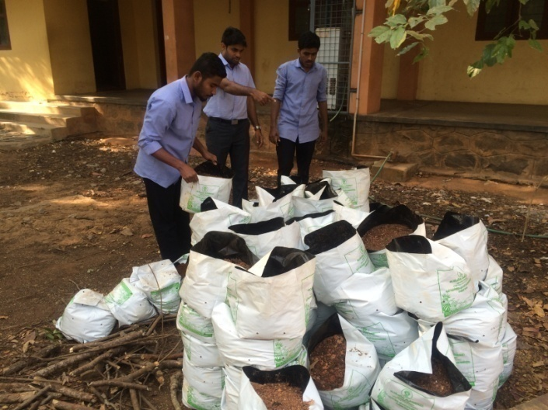

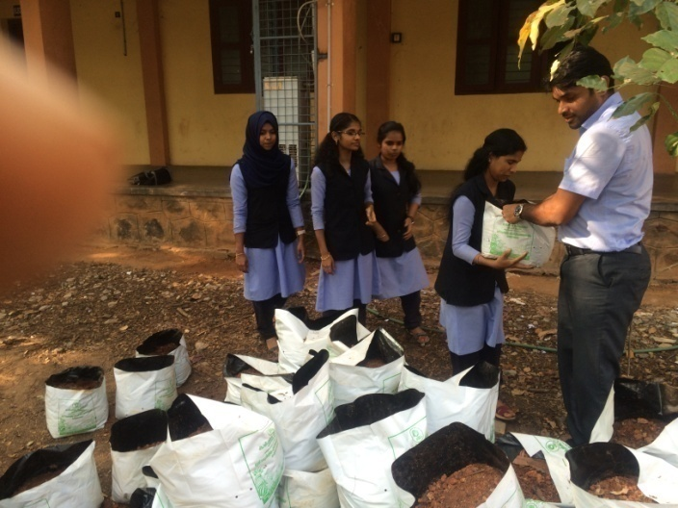

* Apart from grow bag cultivation, organic vegetables and Banana pants were cultivated in the back side of Haroon Memmorial Hall.
* Mrs. Shamila, one of the coordinator had visited Ponnani Krishi Bhavan to enquire about various schemes of organic farming in educational institutions.
* On 18th January 2017, a group of club members arranged a plastic picking campaign in front of Commerce Department. Around 5 sack of plastic had picked them and cleaned that area of the campus.
* On 19th January 2017, roadside area in front of the campus was cleaned

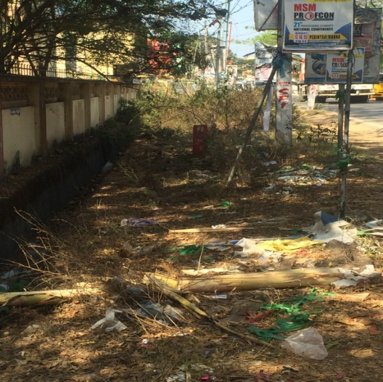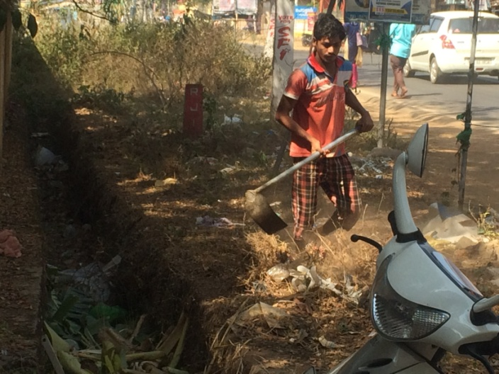

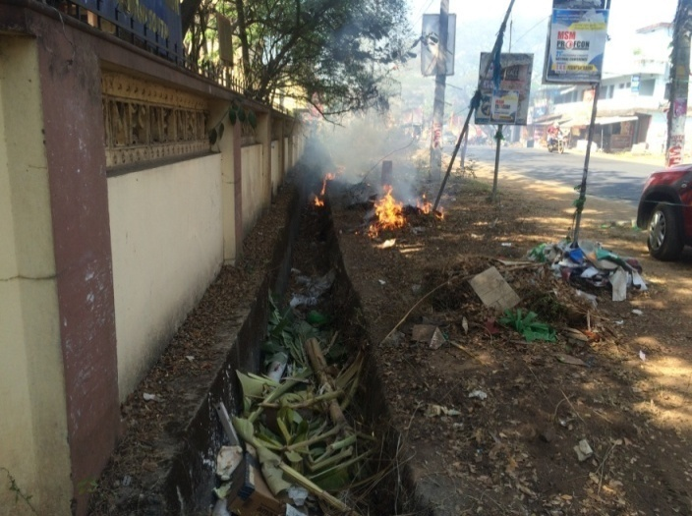

* On 27th January 2017, the club members organized a plastic picking campaign in the back side of the main building. Members collected around 3 sacks of plastic wastes and cleaned the area.
* On 7th March 2017, the members actively participated plastic picking campaign close to canteen and around 6 sacks plastic waste had collected and properly cleaned that area

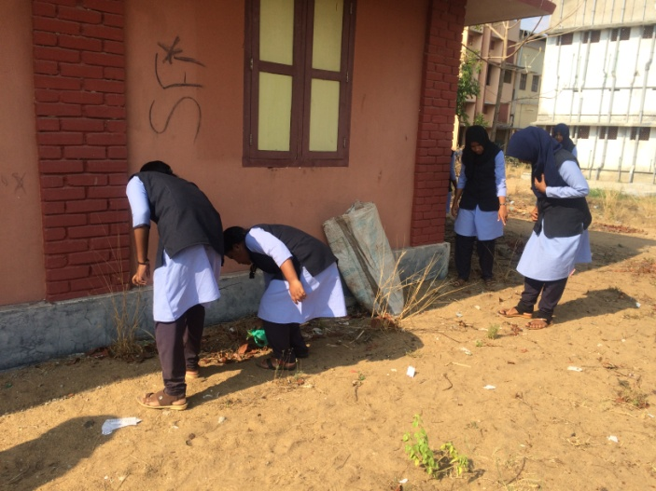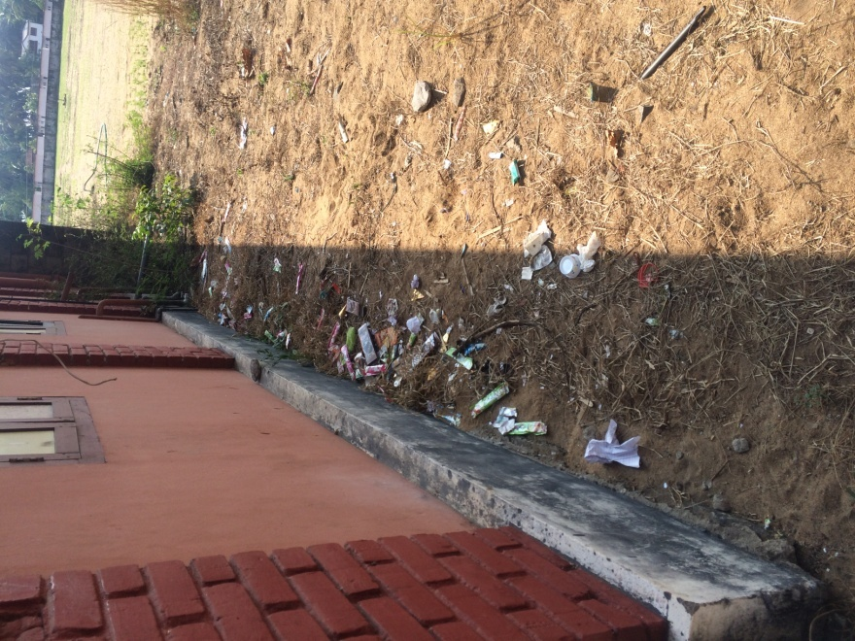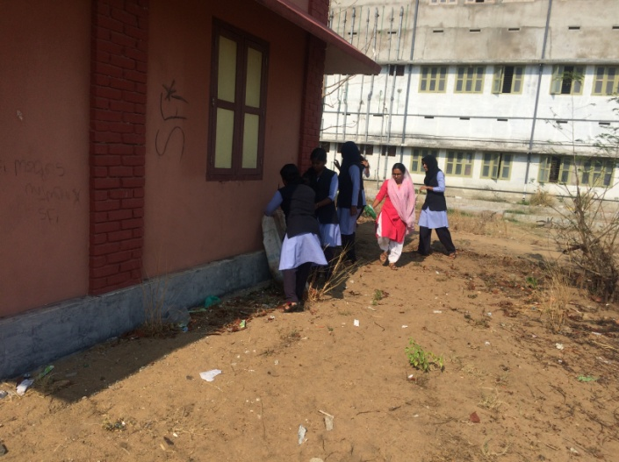

* On 9th March 2017, another plasic picking and cleaning campaign was organized nearby the Auditorium area.

